13. Mastering to Tape

Once you have completed the entire project you are ready to play it out to tape.

Make sure the edited program is preceded by a minute of clock (BATV3 course requirements involve having 2mins of bars/tone/clock before the program begins at 10.00.00.00). Therefore, place the 40second Bournemouth University clock and, either 20secs of black or 20secs of still clock before that.
You should also add the Bournemouth University trailer to the end of your program.

- To add the Bournemouth University Clock to the beginning of the program, select Import from the File menu.
Navigate to where the BU Clock is stored (Temporary Work Folder). Select it from the list of files.
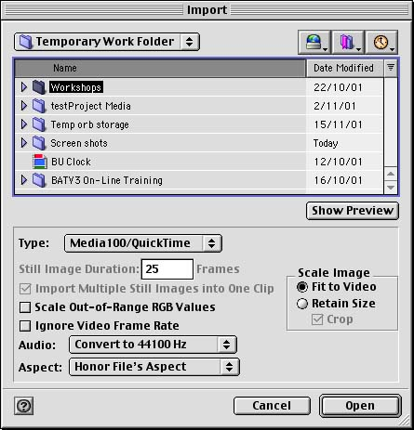
Ensure the file Type: is set to Media 100/Quicktime, and click Import.

The BU Clock will appear in the Bin like any other video clip, which can then be edited into the program.

To add the Bournemouth University Trailer to the end of the program, you must first import it in the same way as the clock.

Ensure all video effects and titles are rendered.

If you are adding widescreen bars, you probably wont want to render them, as it could take hours! But ensure everything else is rendered. Media 100 will not want to play out properly if it has to play – at real time – two unrendered shots.

- To render everything in the program select Render from the Media menu.

This gives you a window listing everything that can be rendered, e.g. video or titles. Select all the elements required and click Render.
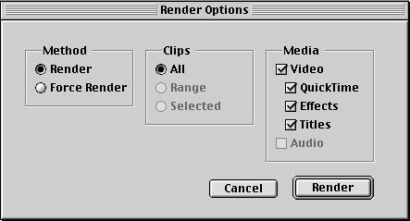

This will render everything in the Program.

Select Save Program in the File menu to save your final edit.

You are now ready to master to tape.

- It is very important to set the audio correctly before you master to tape.
It is best to end the on-line with only two audio tracks to play out to tape. Therefore all these sounds can be individually edited in PPS. Although it is possible to have eight tracks of audio this could get a tad confusing, especially as only two are really necessary.

In any case, pan (or send) the tracks to different channels (A1 to left, say, and A2 to right. If there are more tracks send A3 to left, A4 to right…), ensuring you never send different sounds to the same channel, at the same time.

You must pan the audio tracks twice:
Once on the audio mixer - Pan each track to different sides.
Secondly on Media 100 - Highlight track A1 and select Pan Track from the Track menu.
Change central to the correct direction, i.e. left.
Highlight track A2 and do the same again, but panning it to the right.

Lastly, play through the program and set the levels on the DV machine.

- If you need more than two tracks for you PPS, you can master your program twice: Once with A1 and A2 only, and all the rest muted. Then again with A3 and A4 only, and all the rest muted...
All these audio tracks can then be played into P.P.S. and synced up, using the tone that Media 100 writes onto the tape, as a sync point.

Select Master to Tape from the File menu.

A new window opens where you can set all the parameters for playing your program out to tape.

Select Record as the editing mode. You do not want Assemble or Insert selected if you are simply editing to tape. (An assemble edit is designed for tape to tape editing and makes use of the timecode already burnt into the tape. Insert edits can be used to fix mistakes or insert a new shot if necessary. Insert edit inserts it’s own timecode also, however.)
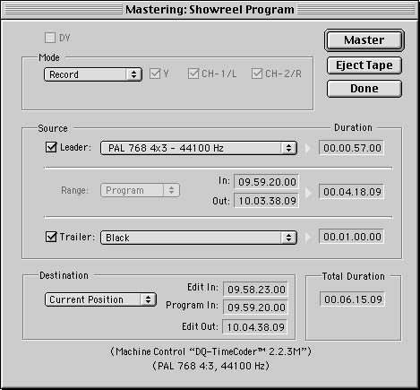
Ensure Leader is selected (There is a cross in the box next to it). Change the leader from black to PAL 768 4x3 – 44100Hz (This is the Bars and Tone that must precede the program). The length of the leader will automatically change to 57seconds.

Selecting a Trailer is not a necessity but you may want to add a trailer of Black. Put the length of the black clip required into the relevant timecode box.

Ensure Program is selected rather than Range.

Set the Program in point in the central timecode box at the bottom of the window. This does not refer to your edited program, but the contents of the Program window.
Therefore you must insert the timecode at which the contents of the Program window will begin on the tape.
As the edited program must begin at 10:00:00:00, and you have placed a minute of clock before that, then the Program itself begins a minute earlier, i.e. 09:59:59:00.
So the Program in should be set to 09:59:59:00.

Media 100 then calculates the Edit in to be 09:59:58:03, taking the 57secs of bars and tone into account, and the Edit out to be the end of the program and the trailer.

Ensure the tape is set to record at the Current Position, rather than the Beginning of tape or at a specific Timecode.

Make sure the tape is in the correct place.

When you are ready to master, select Master.

Media 100 will now play the entire project out to DVCPro, complete with burnt in timecode.

- If the sound is not in sync with the image as you play out to tape, press the 2TK Return button as normal to put it into sync. This will NOT affect what is being recorded to the tape.

