- Transitions

A transition is a change from one clip to another. This can be a cut, a dissolve or a wipe.

To create a transition, expand the Video track in the Program window. This reveals two video tracks, a and b, and an fx track.
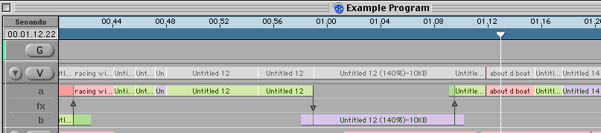

Place one video clip in track a and another in track b, so that the two overlap.
An arrow appears in the fx track. It points from the clip that comes first in the timeline to the clip that follows and indicates the point at which the cut will occur.
By double-clicking on the arrow, the Edit Suite will automatically go into Transition mode and the two clips will be in the Edit Suite’s viewer

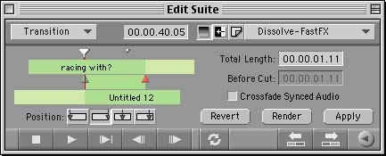

The Edit Suite now represents what is in the Program window.
The top green bar is the clip in track a and the bottom green bar is the clip in track b. The central green block is in the fx track and represents the length of the transition. (The green triangle is the in-point, the red one is the out-point)

The length can be varied either y dragging out the in and out points, or by entering a length into the Total Length timecode box.

It is also possible to alter where the transition begins/ends in relation to the cut between the two clips:

Starts the transition at the cut

Ends the transition at the cut

The transition happens evenly either side the cut
You can customise how long the transition is and how much of it is before the cut (in the Total Length Before Cut timecode box.

You then need to select what sort of transition you want to apply.

Dissolve – This puts a dissolve menu into the transition box. There are four types of dissolve to decide between
Wipe – This menu includes a number of wipes, with both Fast-fx and non-Fast-fx options.
Digital Video Effects – This menu has a large number of effects. DVE’s look like wipes, but with a wipe, the first shot wipes off the screen to reveal the second, whereas in a DVE the second shot physically pushes the first off the screen, or replaces it.

Certain attributes of various wipes can also be modified.
Expand the Edit Suite window to reveal the Transition Settings window.
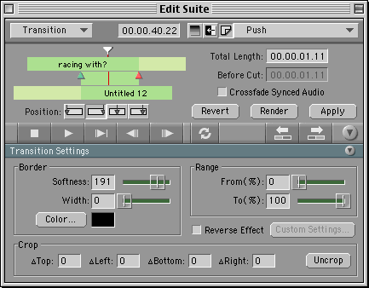

The main change that you may want to make is to apply and modify a border.

Click and hold on the slider next to Border Width to make the border thicker.
Click and hold on the slider next to Border Softness to make the border softer.

- Whilst you drag the sliders, the wipe’s border will change, but the Edit Suite will not update until you release the mouse.

You can also change the border colour. Click in the Colour box.

The new colour picker window will open.
The panel down the left side of the window allows you to choose which mode you will pick colours in – such as from colour wheels, crayon picker, or by RGB or YUV values.
Select the desired colour and click OK.
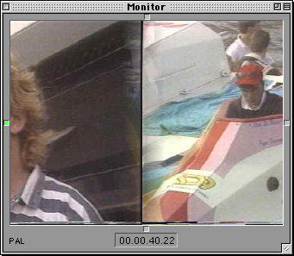

Some wipes are also directional. For these wipes small grey boxes surround the monitor. Highlight one of the boxes (it goes green) to tell the wipe where to begin.
For instance, this wipe is a push moving from left to right, as indicated by the green box on the left-hand side.

The changes will update in the Edit Suite window.

Once you have selected and modified the transition you want, click Apply.
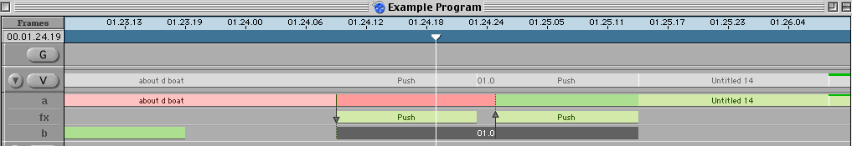

This applies the effect to the Program itself, and a green block appears in the fx track.
Dissolves and Fast-fx wipes can be viewed in the Program without first rendering them. The un-rendered block in the fx track is a turquoise colour.
Other wipes and DVE’s cannot be viewed in the Program without first rendering, although it can be watched in the Edit Suite. These un-rendered blocks are dark green.

To render the effects take the wipe or dissolve into the Edit Suite (it will go into Transition mode) and select Render.

Remember that the transition in the fx track can be treated like a clip: it can be selected and deleted, lengthened, shortened or moved. However this will make the clip un-rendered.

