7. Audio in Media100

Although the audio is best edited in PPS it is possible to alter it in a number of ways.
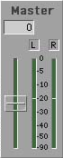

When editing the most important thing to do, with regards the audio, is to ensure that the levels (the Master tracks in the Audio window) average at the white line, peaking slightly higher.

Working with multiple Audio Tracks
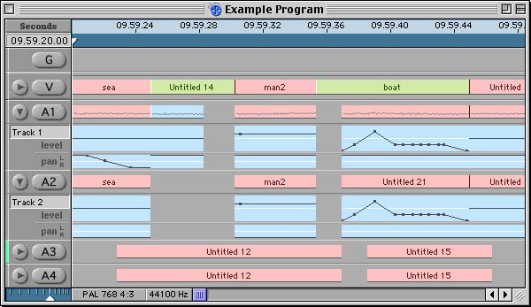

A number of tracks are available by default, when a new Program is opened: One Graphics and Video and two Audio tracks. It is possible, however, to add two further audio tracks at the off-line stage, and another four in the on-line.

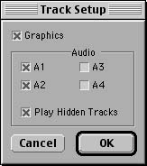
To alter the set-up of the Program window, select Track Set-up from the Track menu. Graphics, A1 and A2 are automatically selected. To add more audio tracks, select the boxes by A3 and/or A4.

Click OK and the Program window will update the changes.

Reallocating Audio Tracks
Quite frequently when you are editing you will want to change where you send edited clip’s audio, i.e. you don’t always want a clips synced sound to go to A1 and A2. The easiest way to alter this is when you first edit a clip, before you place it into the Program window. Double-click on the relevant clip, to put the Edit Suite into Edit Clip mode.
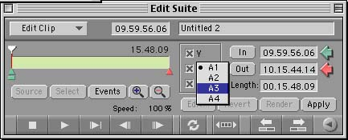

Select the audio destination of either of the highlighted audio tracks. It is now possible to select any of the four available audio tracks, to reallocate where the clip’s audio tracks will go.

Editing Audio Levels/Panning Tracks
To edit either the audio levels or to pan a clip to a certain channel (or effectively speaker), you must first expand the audio track. To do this, click on the arrow to the right of the track name.

This reveals two black lines. The top one controls the level (or volume) and the lower one pans the sound – The black line is always automatically in the centre (therefore the sound is being sent to both channels), but it can be moved to pan the sound left or right.
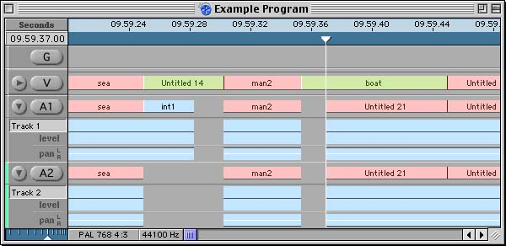

Editing the Levels
To change the level of an entire clip, click on the line and drag it up or down, to raise or lower the sound respectively.

If you want to alter levels across the duration of the clip, i.e. fade the sound, click on the line in a number of places. This adds black dots, or nodes, to the line.
Each of these dots can then be manipulated individually to achieve the required level.
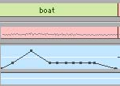

It is now possible to make certain sections quieter, and others louder by altering the height of the line, and the gradient of fades.

- It is very useful to be able to hear a clips audio, as you drag the playline across it. To enable this function, select Scan Audio from the Tools menu. With this on it is also possible to hear the level of a clip as you alter it.

If, once you’ve altered a clip, the entire thing is too quiet or too loud, there are two ways to alter the entire level:
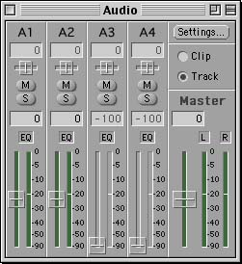
- Holding down Alt click on the level line and drag it up and down. The level of the entire clip will be raised or lowered, whilst maintaining the edited nodes.
- Alter the faders for the relevant track in the Audio Suite window. With Track selected it applies this change to all the clips in the track, but with Clip selected it merely changes the overall level of the clip. Like the first method, this maintains the changes made to individual nodes.

Panning Audio
By panning the tracks it is possible to control which channels (right or left) the audio is sent to, and therefore recorded onto.

It is possible to pan the audio for either individual clips, or entire tracks.

Expand the audio tracks and move the pan line to left, right or centre, or insert nodes to edit it more accurately.
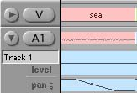

Alternatively, highlight a track and select Pan Track from the Track menu. Then select the direction: mono, left, centre or right. This pans all the clips on the highlighted track.

Mono – Distributes the signal equally between both channels and adjusts the gain to
compensate for the diminished single channel level output. Use this setting to master your program if you only have a single track of audio.
Left – Distributes the signal entirely to the left channel.
Centre – Distributes the signal equally to both channels.
Right – Distributes the signal entirely to the right channel.

Editing Using an Audio Waveform
This function is most useful when editing to a beat, say when cutting to music. It reveals the waveform of the sound in the audio track, and allows you to identify certain beats and sounds by looking at the peaks and troughs in the waveform.

To enable this function, highlight an audio track and select Show Audio Waveform from the Track menu. This displays the audio waveform for every clip, in the selected track.

Creating Audio Crossfades
Crossfades combine the sound of two clips, about a cut, in the same audio track, fading down the tail of the first clip, whilst simultaneously fading up the leader of the second clip. They ensure clean audio transitions and can be created between single audio tracks, or synced clips on a number of audio tracks.
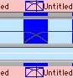
To create an audio crossfade, hold down OPTION and move the pointer to the relevant cut. The trim pointer will turn blue indicating that it will create an audio crossfade, rather than edit the cut. Drag the pointer to create the crossfade.

It is also possible to choose between a variety of types of audio crossfades. Select Crossfade Type from the Program menu to get a list of the six options. These are:

Equal Power Fades the first clip out as the second fades in, with no change in volume level across the crossfade.
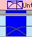
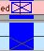
Linear Fades the first clip out and the second in at a constant rate. There is a dip in volume at the halfway point.

Exponential Fades the first clip out gradually as the second fades in gradually. There is almost silence at the halfway point as the clips’ volumes are both low.
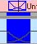
Classic Fades the first clip out slowly, whilst the second fades in
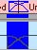
Equal Power quickly, with no change in the overall volume.
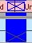
Classic Fades the first clip out at a standard rate, as the second clip
Linear fades in quickly. There is a noticeable dip in volume at the halfway point.
Classic Fades the first clip out gradually as the second clip fades in
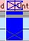
Exponential quickly. There is almost silence at the halfway point.

Customising Crossfades
A crossfade can still be edited, once it has been created. For example, a crossfade can be moved just like a clip. Position the pointer over the crossfade you want to move. A hand with a blue marker appears, and it is now possible to move the crossfade, so long as the move is within the bounds of the available header and tails frames.
In a similar way it is possible to shorten an audio crossfade.

Although a crossfade alters each clip’s audio level, you can still edit the incoming and outgoing levels in the same way as you edit the volume of any audio clip.
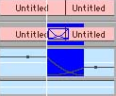
By altering the level line of the clip preceding or following the crossfade, the levels within the crossfade will change accordingly.

Creating an Audio Crossfade in conjunction with a transition
To create an audio crossfade in conjunction with a transition, overlap the video clips as usual, ensuring that the audio clips abut each other, on the same audio track.
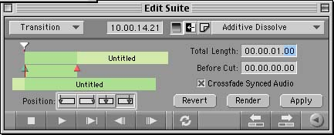

Create the transition as usual (See 6. Transitions in Media 100), but whilst the Edit Suite is in Transition mode, select Crossfade Synced Audio.

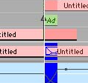
Select Apply, and both the transition and the crossfade will be applied to the Program.

Audio and EQ
This function is not available in off-line Media 100 so any editing of audio must be left until the on-line or Post Production Sound stages.

