To create Pseudo-Widescreen
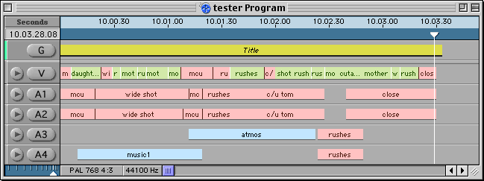

Create a title that runs the length of your program.

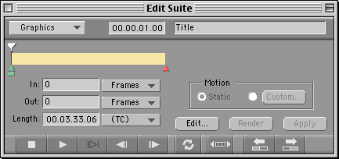

Hit Edit in the Edit Suite to go into Boris Grafitti.

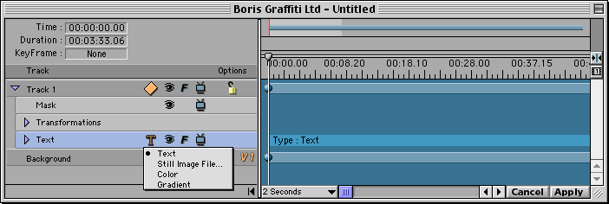
Expand Track 1 in the Timeline window.
Select the Source Media icon and select Colour.

The colour picker will appear, select black and hit OK.

You will have a black image the size of the screen.
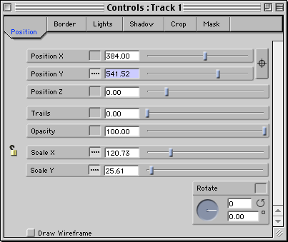
Click on Transformations (for track 1) in the Timeline window, to change the Controls window into Transformations mode.

Now you can resize the screen of black along the y-axis only (click the padlock to disable ‘preserve aspect ratio’ and alter the scale value for the independent dimensions).

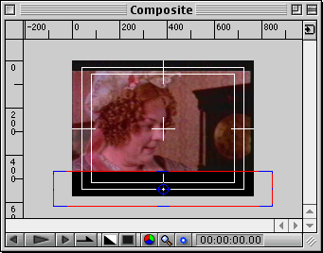

Move the black bar to the bottom of the screen, by dragging the crosshairs in the Composite window.

Now, to create the other bar select Duplicate Track from the Edit drop menu, ensuring Track 1 is highlighted.

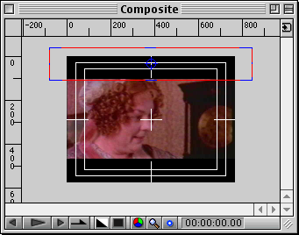
This duplicates the track exactly, so now you have two black bars at the bottom of the Composite window.
Move track two to the top of the screen.
Position the two title tracks until you are happy with them.

Select Apply in the timeline window to apply the title to Media100.
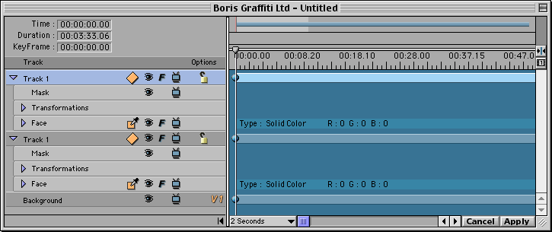

When back in Media100, ensure the title is as long as your program and render it.

If you are in on-line you do not have to render the widescreen bars to be able to play them out. In fact rendering a title at least 4mins long at such high quality
will take a substantial amount of time and memory. So, play it out without rendering.
If there is a problem during mastering, cut up the title into smaller sections and render every other one. This should ease any problems.
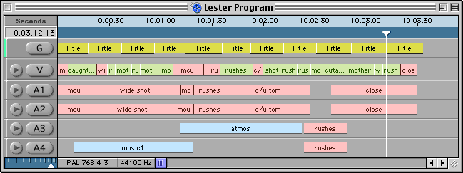

In off-line: Do not render until you are happy with the whole piece, if you make any change to the video track, the title will become unrendered and each time you render it more memory will be used. (Hit undo if you accidentally move something and it comes unrendered).

If you don’t have much memory on your ORB, set up media destinations so that G (Graphics) is armed for the Temporary Work Folder only, so then the title will be saved there. If you do this, however, make sure you render in the digitising suite you intend to play out in. You wont be able to access a title saved in one Temporary Work Folder from another machine.

