Taking a still shot from of Media100

Place the playline on the exact frame you want.

Next select Export from Edit Suite in the File menu.

The Save Exported File as: window will appear.
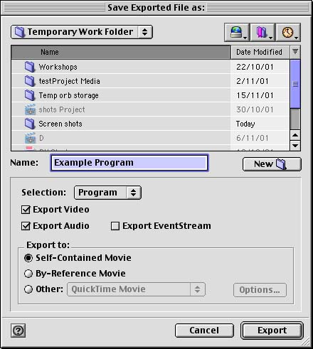
Make sure you are saving the shot to the right place.

Name the shot.

Make sure Selection: is set to Frame.

Only the Export Video box need be selected.

Then hit Export

To export the frame as a different file type, select the Export to: Other check box. Now click Options to be able to select a different file type, just as PSD, JPEG or TIFF.

