PhotoShop 6

Selection techniques.

Magic Wand

This tool selects areas of similar colour. It is therefore useful for extracting objects from backgrounds where there are obvious colour differences between background and foreground.

To make a selection, click on the area you want to select. If too many or too few pixels are selected you need to change the Tolerance setting for the tool. This appears within the option bar when the Magic Wand tool is being used. It determines how close in colour value pixels need to be in order for them to be selected. A low number means that they have to be very close in value, a high number (up to a 100) means that they can vary by a substantial amount.

Experiment with different Tolerance values to select the area you require. If you fail to select the entire area, hold down the Shift key and make further selections. Doing this will add to your selection.

If you want to subtract areas, hold down the Alt key and click on areas you want to deselect.

You can use any other selection tool in the same way. Sometimes it is quite useful to eliminate large areas that have been selected by mistake. To do this use one of the Marquee tools while holding down the Alt key. The Lasso tool can also be very useful in terms of adding to or subtracting from selections.

To help make better selections, you can use the Grow command. This increases the number of pixels selected according the Tolerance value set. Go Select > Grow to see the effect this command has. Again you will need to experiment to find the best Tolerance settings.

Another command that can help you make better selections is Smooth. This tries to work out the area you are attempting to select and eliminates any areas that have not been selected. This can clean things up and save a lot of work. Go Select > Modify > Smooth.

Pen Tool

The Pen tool does not create a selection directly. Instead, it creates a path, which can be turned into a selection at any time. The advantages of using this tool are:

- Paths are reusable
- Paths are editable
- Paths are accurate

Drawing curves with the pen tool

You create curves by dragging the pen tool in the direction you want the curve to go. Keep these guidelines in mind when drawing curves:

* Always drag the first direction point in the direction of the bump of the curve, and drag the second direction point in the opposite direction to create a single curve. Dragging both direction points in the same direction creates an "S" curve.

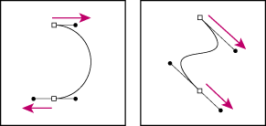
Drag in the opposite direction to create a smooth curve. Drag in the same direction to create an "S" curve.

* When drawing a series of smooth curves, draw one curve at a time, placing anchor points at the beginning and end of each curve, not at the tip of the curve. Use as few anchor points as possible, placing them as far apart as possible.

To draw a curve:

1 Position the pointer where you want the curve to begin, and hold down the mouse button. The first anchor point appears, and the pointer changes to an arrowhead.

2 Drag in the direction you want the curve segment to be drawn. As you drag, the pointer leads one of two direction points. Hold down the Shift key to constrain the tool to multiples of 45°, and release the mouse button once you have positioned the first direction point.

The length and slope of the direction line determine the shape of the curve segment. You can adjust one or both sides of the direction line later.

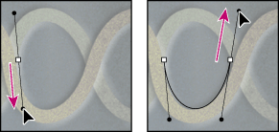
Drag in the direction of the curve to set the first anchor point. Drag in the opposite direction to complete the curve segment.

3 Position the pointer where you want the curve segment to end, and drag in the opposite direction to complete the segment.
4 Do one of the following:

- To draw the next segment of a smooth curve, position the pointer where you want the next segment to end, and drag away from the curve.
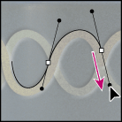

Drag away from the curve to create the next segment.

- To change the direction of the curve sharply, release the mouse button, then Alt-drag (Windows) or Option-drag (Mac OS) the direction point in the direction of the curve. Release Alt (Windows) or Option (Mac OS) and the mouse button, reposition the pointer where you want the segment to end, and drag in the opposite direction to complete the curve segment.

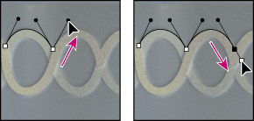
* To break out the direction lines of an anchor point, Alt-drag (Windows) or Option-drag (Mac OS) the lines.

Alt-drag or Option-drag the direction point toward the curve. Release the key, and drag in the opposite direction.

Using Paths
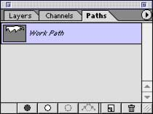
The Pen tool creates a path that can be saved for future use. In order to save a path, go to the Pen tool palette (Window > Show Paths) and double click on the area called Work Path. Enter a name for your path in the window that appears and click OK. Your path is saved.
Creates new path
Deletes path

Converts selection to a path
Fills path with Foreground colour
Strokes path with Foreground colour
Converts path to a selection
Converting a path into a selection

Once you have created and saved a path, you can convert it into a selection from within the Paths Palette. Simply click on the icon shown above. This can be very useful for reselecting areas of a particular outline or making selections very accurately using the Pen tool.

Converting a selection into a path

You can also convert a selection into a path from within the Paths palette (see above). This makes your selection editable using the Pen tool.

Other functions

The Paths palette also allows you to fill the area with the path with the Foreground colour. This is useful for making masks. Click on the icon shown above, In addition, you can “stroke” a path. This turns the path into a physical line that can be used within your artistic creation.

